AI Use Declaration Form
Course: Introduction to Artificial Intelligence
Lab Title: Lab 1 Part A — Lab 4 LLMs and Prompt Engineering for Decision Support
Student Name: Desmond Boateng Barimah
Student ID: 44752028
GitHub Repository Link: https://github.com/dbbarimah/Intro_to_Ai
Date Submitted: 16th August, 2026

1. AI Use Summary
Question | Student Response
Did you use any AI tool for this lab? | Yes
Estimated percentage of the work influenced by AI | 20 %
Did you attach evidence of AI use where applicable? | Yes

2. Details of AI Use
Complete the table below for each AI tool used. Add more rows where necessary.
Name of AI Tool Used | Purpose for Using the Tool | Prompt or Instruction Given to the Tool | Part(s) of the Work Influenced by the Tool | How I Verified, Edited, or Improved the AI Output
Claude | The tool was used to understand fundamental concepts in relation to the assignment |  | Environment Setup, Debugging, Running the file | I did additional research to understand how and why some things work the way they do.
Claude | The tool was used to verify correctness and help in debugging | “Am I on the right track?” | All Sections | I adjusted my code based on what I was given by the AI and my personal understanding of the issue to clear errors.

3. Attachment of AI Output Evidence
Where required, attach evidence of AI use. Tick all that apply. Add more rows where necessary.
Evidence Type | Attached? (Yes, No, N/A) | File Name
AI-generated draft
Prompt history
Screenshot of AI interaction | Yes | 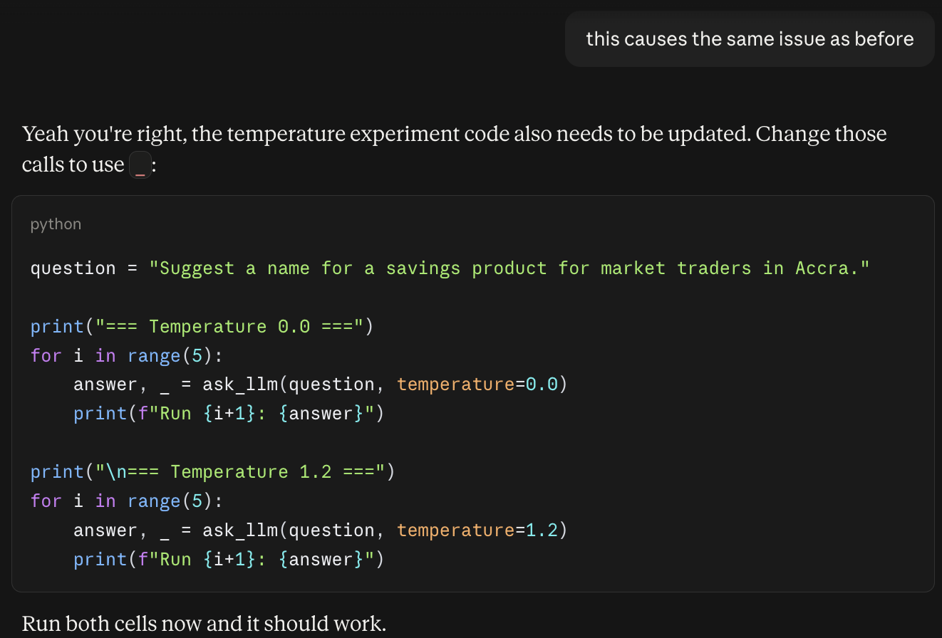  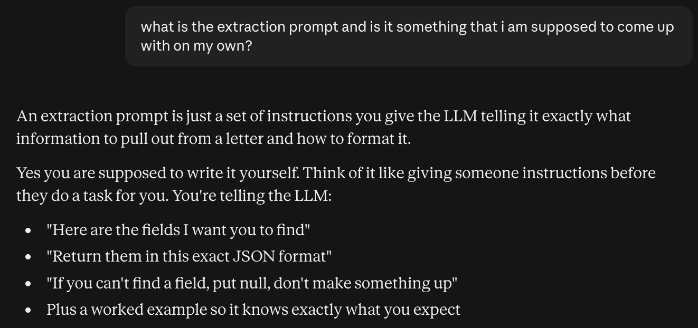  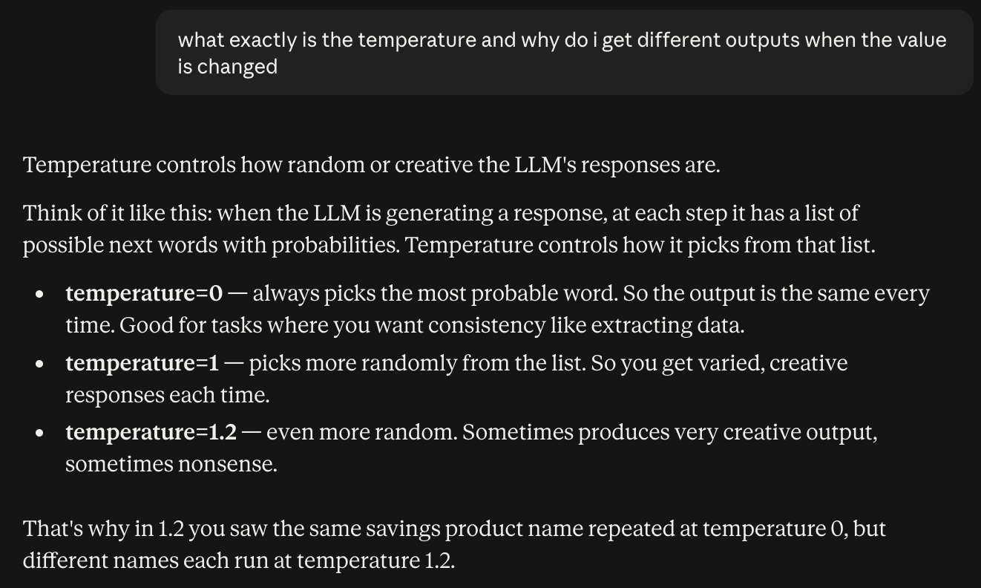  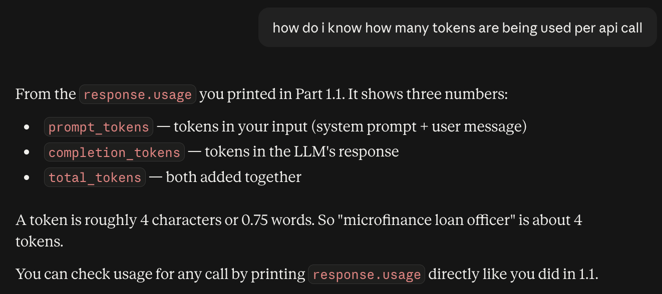  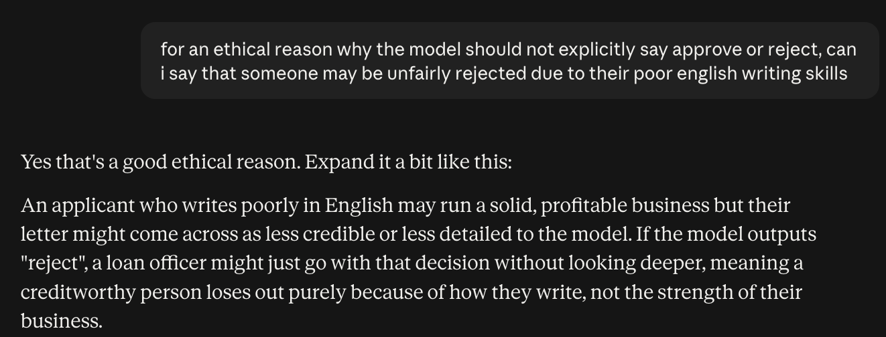
Exported AI conversation
AI-generated code snippet
Revised version showing student input | Yes | 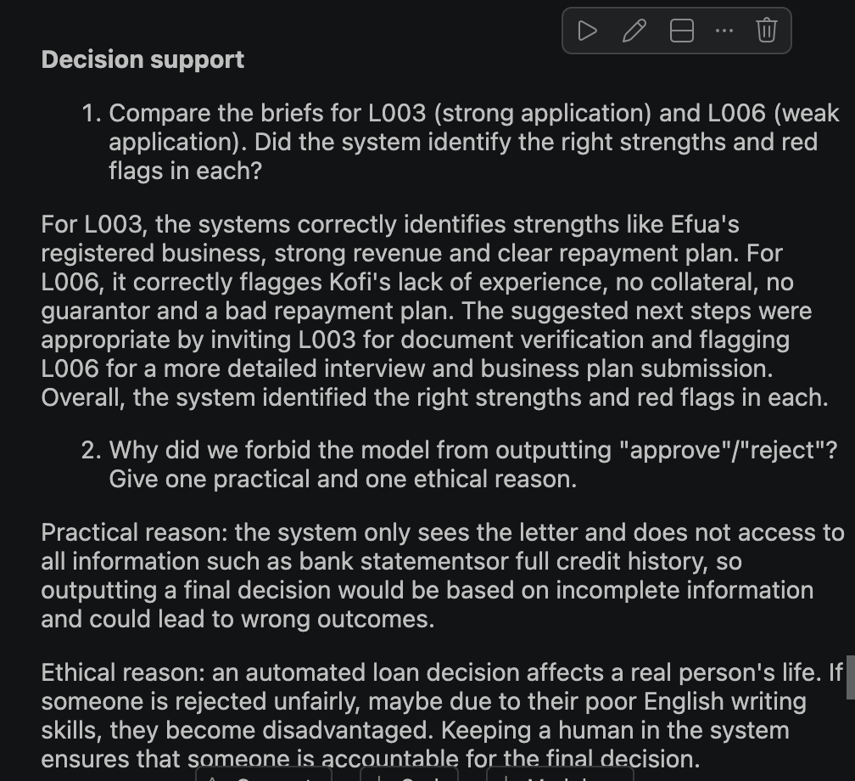

4. Student Declaration
I declare that:
Declaration Statement | Response (Yes/No)
The submitted work is my own work. | Yes
Any use of AI tools has been clearly declared in this form. | Yes
The prompts, instructions, and AI-generated outputs have been disclosed where applicable. | Yes
I reviewed, tested, edited, and improved any AI-generated content before submission. | Yes
My AI usage does not exceed 25% of the entire work. | Yes
I understand that undeclared or excessive AI use may be treated as academic misconduct. | Yes

Student Signature: D.B.B.
Date: 16th August, 2026

